22DP012 | Exhibition of draft planning proposal - zone and building height amendments - former Pasminco site

Key focus area | 1. Unique landscape
Objective | 1.3 New development and growth complements our unique character and sense of place
File | RZ/8/2021 - D10755777
Author | Strategic Landuse Planner - Kent Plasto
Responsible manager | Manager Integrated Planning - Wes Hain
Previous items | 22SP052 - Planning Proposal - zone and building height amendments - former Pasminco site - Ordinary Council - 23 May 2022 6.30pm

Address: | Various lots on the former Pasminco site
Owners: | Hunter and Central Coast Development Corporation (HCCDC)  OOT Developments Pty Ltd  Greencapital Weemala Pty Ltd  Transport Asset Holding Entity of NSW  Lake Macquarie City Council  COSTCO Wholesale Australia Pty Ltd
Applicant: | Lake Macquarie City Council

Executive Summary
This draft planning proposal seeks to rezone land and increase building heights at 144 and 146 Munibung Road, Boolaroo. Additionally, a number of minor zone and building height boundary adjustments are proposed to various lots in the Cockle Creek precinct to align with property boundaries.
The proposed amendments are the result of a strategic review of the Cockle Creek Precinct and seek to facilitate the desired economic development of land at 144 and 146 Munibung Road, Boolaroo. The proposal also seeks to establish a suitable zone for land located between Cressy Road and the containment cell at 144 Munibung Road, Boolaroo.

Recommendation
Council:
- requests a Gateway Determination from the Department of Planning and Environment, pursuant to the Environmental Planning and Assessment Act 1979, in relation to the draft planning proposal for the site, as contained in Attachment 1
- undertakes consultation with State Government agencies and service authorities in accordance with the Gateway Determination
- places the draft planning proposal on exhibition, subject to the outcome of the Gateway Determination
- notifies stakeholders and affected landowners of the public exhibition period as required, and
- receives a further report on the planning proposal following public exhibition.

Discussion
The subject land is located on the former Pasminco Cockle Creek Smelter (PCCS) site, Boolaroo. In November 2005, following the closure of the Pasminco smelter, Council adopted land use principles for the site, that:
“reinforce the economic opportunities in the Cardiff/Glendale/Warners Bay/Edgeworth corridor by investigating a land use strategy that would encourage job creation to replace those jobs lost through the closure of Pasminco smelter, and further employment opportunities.”
More recent investigations regarding the Lake Macquarie North West Catalyst Area (NWCA) and a review of the high-level strategic direction for the area have identified the following vision for the PCCS site:
“A city landmark that promotes Lake Macquarie’s leading role in the region and State and generates excitement, attracts visitors, workers and customers from outside of the city. It develops new housing and employment opportunities that contribute to the economic diversification and development of the city.”
The draft planning proposal seeks to aid implementation of this vision and earlier principles by:
- rezoning land south of Cressy Road at 144 Munibung Road, Boolaroo from Zone SP1 Special Activities Hazardous Storage Establishment – Containment Cell to Zone B4 Mixed Use
- rezoning land north of Cressy Road at 144 Munibung Road, Boolaroo from Zone SP1 Special Activities Hazardous Storage Establishment – Containment Cell to Zone RE1 Public Recreation to facilitate possible end of trip and other public facilities
- increasing building heights on part of 144 Munibung Road, south of Cressy Road, from 8.5m to 18m and at 146 Munibung Road, Boolaroo from 13m to 18m
- resolving minor mapping anomalies at a number of locations on the former PCCS site.
The intended outcome is to increase business zoned land which will provide further opportunity for economic development, as well as providing public open space at a key location. Correcting mapping anomalies will align land use zone boundaries to property boundaries in order to facilitate development.
144 Munibung Road, Boolaroo - Lot 1012 DP 1270101
This site is approximately 7380m² in area and is located adjacent to the containment cell. Recent development associated with Costco has seen the construction of Cressy Road which has dissected the site, leaving two unused land areas to the north and south of the new road. As a result of remediation, the site is predominantly level and clear of vegetation. Until recently, the site was thought to be needed for the ongoing operations of the adjacent containment cell, however, NSW Waste Asset Management Corporation (WAMC) has confirmed this land is not necessary for this purpose. The portion of this site to the north of Cressy Road is proposed to be rezoned RE1 Public Recreation and will be dedicated to Council. The portion of this site to the south of Cressy Road is proposed to be rezoned B4 Mixed Use which is the same zone as the adjacent 146 Munibung Road site.
146 Munibung Road, Boolaroo - Lot 601 DP 1228699
This site is approximately 5610m² in area and is predominantly level and clear of vegetation.
Local heritage item 227 (former laboratory building) is located on 1 Hague Road, directly to the south west of 146 Munibung Road. The proposed increase to building heights has considered possible impacts of future development on the adjacent local heritage item. Current provisions in the Lake Macquarie Local Environmental Plan (LMLEP) 2014 and the Pasminco Area Plan in Lake Macquarie Development Control Plan (LMDCP) 2014 will ensure any impacts from future development on the heritage item are addressed.
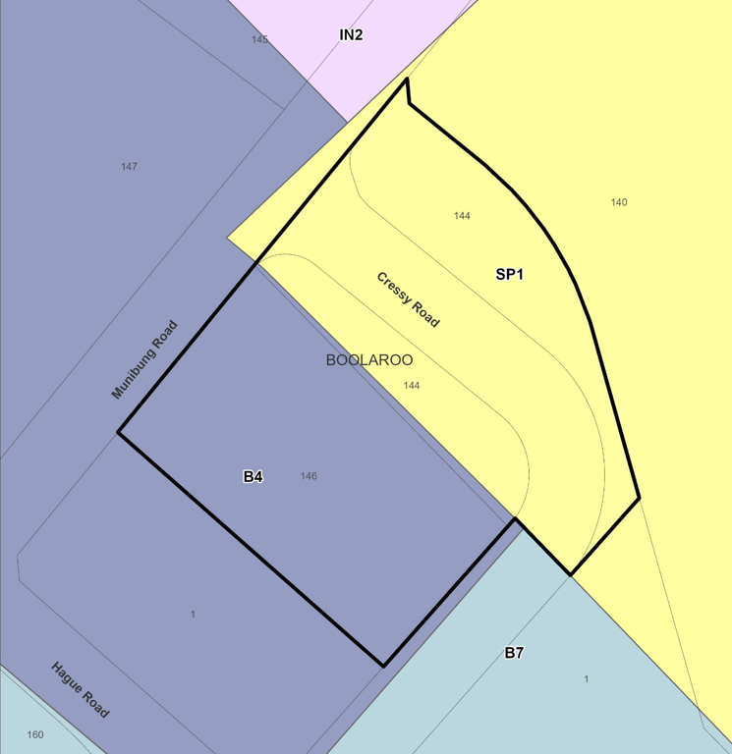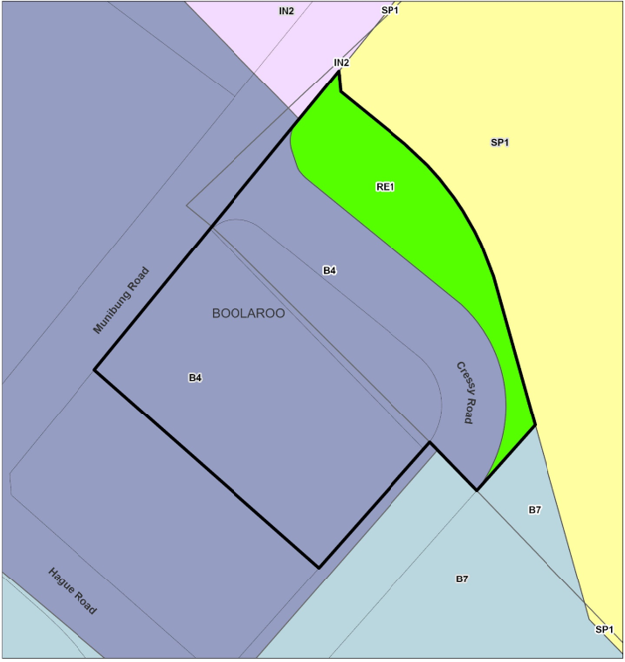
Figure 1 – existing (left) and proposed (right) zones
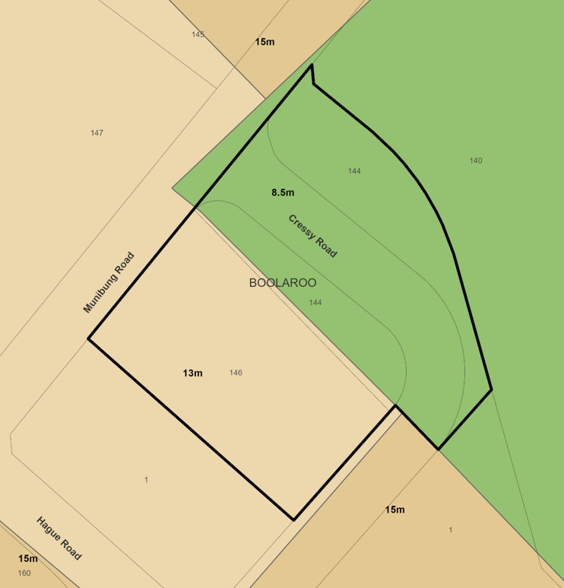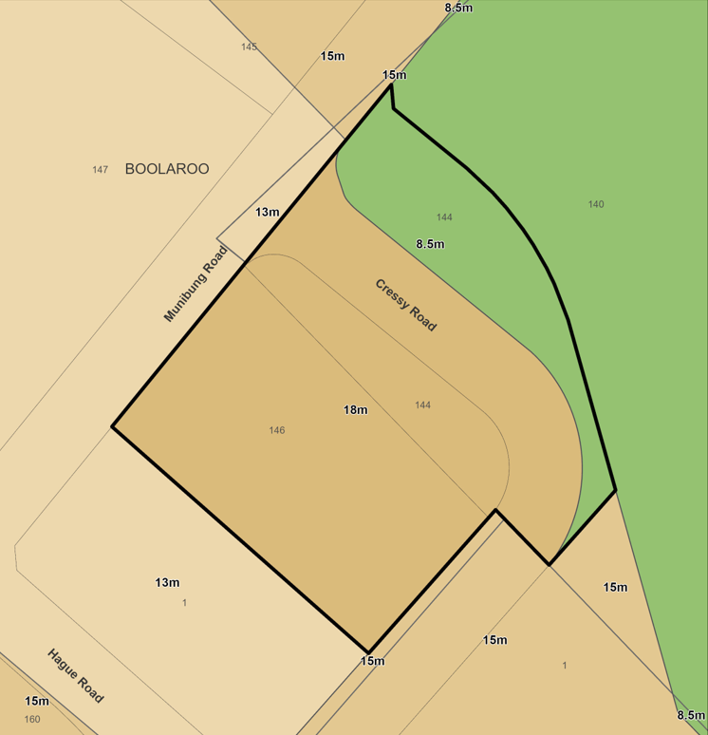
Figure 2 – existing (left) and proposed (right) building heights
Additional land areas with minor zone boundary anomalies
There are a number of minor mapping anomalies where zone boundaries do not correctly align with lot boundaries. These anomalies have resulted from recent subdivisions where registered titles have not always aligned with the land use zone boundaries. The proposal seeks to correctly align these boundaries.

Assessment of options
It is recommended Council supports the draft planning proposal contained in Attachment 1. This will facilitate further economic development of the site that will contribute to the precinct’s leading role in the region. Contamination issues associated with the historic use of the land have been resolved and current provisions in the LMLEP 2014 and the Pasminco Area Plan in the LMDCP 2014 will ensure any future impacts on the adjacent heritage item are adequately addressed as part of any future development application and assessment.
Council may also decide to not proceed with the proposal. This is not recommended as it will limit opportunities for economic development and end of trip recreation facilities at a central location. Retaining minor mapping anomalies will also hinder efficient development of the former PCCS site.

Community engagement and internal consultation
Internal consultation has occurred with Development Assessment and Certification and Integrated Planning staff.
Preliminary consultation has occurred with the Department of Planning and Environment (DPE), Waste Asset Management Corporation and the Hunter and Central Coast Development Corporation (HCCDC). Matters raised by these agencies have been addressed in the draft planning proposal.
At its meeting on 23 May 2022, Council resolved (22SP052) to defer this draft planning proposal pending a Councillor briefing. A Councillor briefing on the draft planning proposal was held on 18 July 2022.
If Council resolves to proceed, the draft planning proposal will be exhibited in accordance with the Gateway Determination. It is recommended the draft planning proposal be exhibited for a minimum of 28 days.

Key considerations
Economic impacts | The draft planning proposal will provide greater commercial/retail and service potential, as well as future employment opportunities for local people on infill land close to public transport and services. The draft planning proposal will result in an increase of employment land in a strategic location within the North West Catalyst Area.  The correction of minor zone boundary anomalies removes uncertainty and enables the economic redevelopment of the land, as appropriate.
Environment | Both 144 and 146 Munibung Road are remediated and cleared of vegetation. The relevant site audit statements identify both sites as suitable for the following uses:  - residential  - day care, pre-school and primary school  - secondary school  - park, recreation open space and playing field  - commercial/industrial.  Assuming the land areas are developed with appropriate stormwater management and remain consistent with the various conditions outlined in the site audit statements, it is not anticipated that the draft planning proposal will have a detrimental impact from a contamination perspective.  Minor zone boundary changes seek to re-align lot boundaries with environmental and ecological land areas, some of which are subject to environmental management plans. It is anticipated this will retain and support ecological outcomes in relevant areas across the site.  Any potential for impact associated with increasing permissible building heights on the adjacent heritage item has been considered during preparation of the draft planning proposal. Any impact from future development will be considered at development assessment stage based on existing heritage provisions in the LMLEP 2014 and LMDCP 2014.
Community | The rezoning of part of the land at 144 Munibung Road as RE1 public open space, although small in size, provides opportunity for end of trip facilities and historical and cultural information about the site and its development in a key position on the Pasminco site.  Increasing capacity for mixed use development opportunities, business and services in a central location will support the growing Cockle Creek and Boolaroo community and reinforce the desired social and cultural character of the area.  Exhibition of the draft planning proposal will provide opportunity for community feedback.
Civic leadership | Council’s support for the draft planning proposal will help achieve the objective to grow and diversify our city’s economy and increase local employment opportunities.
Financial | There will be no direct financial implications for Council associated with proceeding with the draft planning proposal other than staff time reviewing and progressing the draft planning proposal.  It is anticipated the increased heights and alignment of zone boundaries will have some indirect positive financial impacts as the economic and regional significance of the site is further realised over time.
Infrastructure | The Pasminco site has undergone both remediation and development preparation which has included the provision of roads, electricity, stormwater and sewage infrastructure. The subject lands are positioned close to public transport and adjacent to Munibung Road. Other than connecting the specific sites to the existing infrastructure networks, it is not anticipated the draft planning proposal will impact existing infrastructure.
Risk and insurance | The risks associated with preparing a draft planning proposal are minimised by following the process outlined within the Environmental Planning and Assessment Act 1979, the Environmental Planning and Assessment Regulation 2021, and Council’s procedure for Amending Local Environmental Plans.

Legislative and policy considerations
Environmental Planning and Assessment Act 1979
Environmental Planning and Assessment Regulation 2021
State Environmental Planning Policy No 55—Remediation of Land
Lake Macquarie Local Environmental Plan 2014
Lake Macquarie Local Strategic Planning Statement
Greater Newcastle Metropolitan Plan
Pasminco Area Plan 2014

Attachments
1. | Draft Planning Proposal - RZ/8/2021 - 144 and 146 Munibung Road Boolaroo | Under separate cover | D10769371

